**Internet of Things (IOT) Projects using Python**

**End-Term Project Synopsis**

*.*

|  |  |  |
| --- | --- | --- |
| **Group No.** | **Group Members (Regd. No.)** | **Project Title** |
| **11** | **Aditya Raj (1941012673)** | **IoT based environmental parameter monitoring system**  **[Mini weather station]** |
| **Pratistha Chinara (1941012659)** |
| **Bali Babu Chauhan (19410121182)** |
| **Rajshri Gupta (1941012812)** |

1. **Introduction:** (*Details about the Topic, industry, products, need of study and some history about the same etc.)*

The IoT based Weather Monitoring System is used to get the live reporting of weather conditions. It will monitor temperature, humidity, air pressure and altitude.

To accomplish this we used Raspberry Pi Pico and different environmental sensors like DHT11, ESP8266 WiFi Module, bmp280 pressure sensor. The sensors constantly sense the weather parameters and keeps on transmitting it to the online web server over a wifi connection.

DHT11 Temperature and Humidity Sensor features digital signal output.

# The BMP280 is an absolute barometric pressure sensor, which is especially feasible for mobile applications,

1. **Problem identification and Problem Formulation: (***Core area of problems or other related problems and their brief solutions***)**

Climatic change and environmental monitoring have received much attention recently. Man wants to stay updated about the latest weather conditions of any place like a college campus or any other particular building. Since the world is changing so fast so there should be the weather stations.

To accomplish this we used Raspberry Pi Pico and this is a fully automated system. It is a smart way to monitor environmental conditions and gives accurate results.

Use of technology in the field of agriculture plays important role in increasing the production as well as in reducing the extra man power efforts.

1. **Objective of the Project: (***Objectives should be mentioned pointwise. Students can also divide the broader and narrow areas of the objectives. These objectives must be near to the situation of the problems***)**

This weather station is based on IOT (internet of things). It is equipped with environmental on IOT (internet of things)..

It is equipped with environmental sensors used for measurements at any particular place and report in real time.

1. **Block Diagram of the Project: (***Diagram of a system in which the principal parts or functions are represented by blocks connected by lines that show the relationships of the blocks***)**

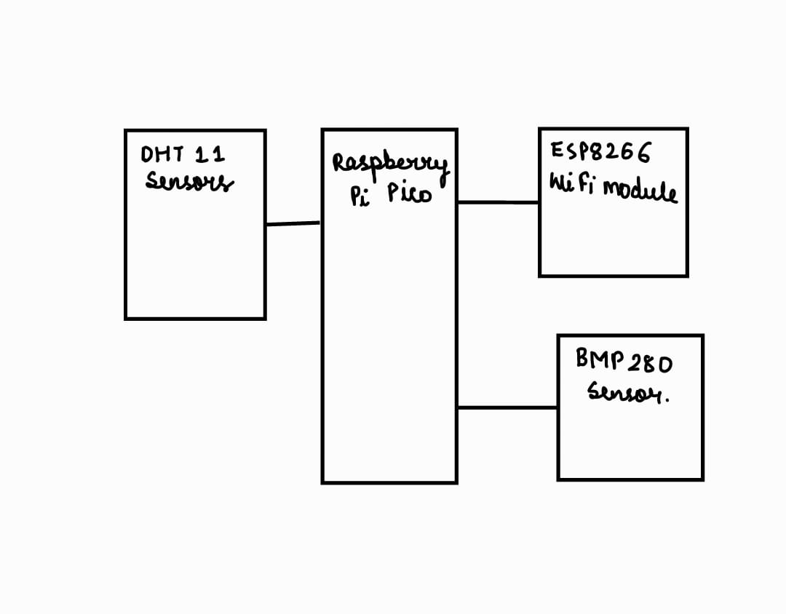

1. **Circuit Diagram of the project:**

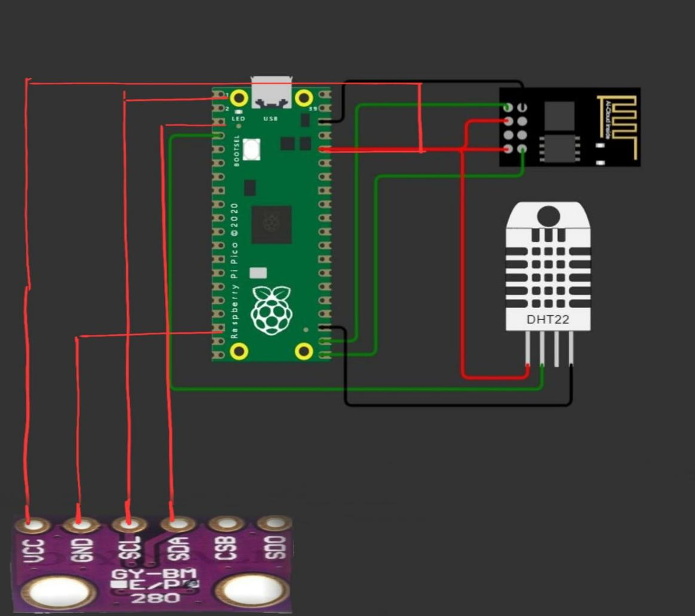

1. **Components/Items Required:**

|  |  |  |  |
| --- | --- | --- | --- |
| **Sl. No.** | **Name of the Components** | **Specification** | **Quantity** |
| **1** | **Raspberry Pi Pico** | **125 MHz** | **1** |
| **2** | **DHT11 Sensor** | **0-50oC** | **1** |
| **3** | **BMP280 pressure sensor** | **2.0 x2.5 mm** | **1** |
| **4** | **ESP8266 WiFi Module** | **2.4 GHz Wi-Fi** | **1** |
| **6** | **resistors** | **10000 ohm** | **2** |

**Signature of Corresponding Faculty**

**Full Signature of Group members:**

**1.**

**2.**

**3.**

**4.**